**POSTER CONTENT**

**[**\*Old names in the poster, to be replaced by written before brackets.**]**

**[Suggeted colors:** Background: Grey  
Text color/Headings Bars: navy blue**]**

**[Sample Format:**

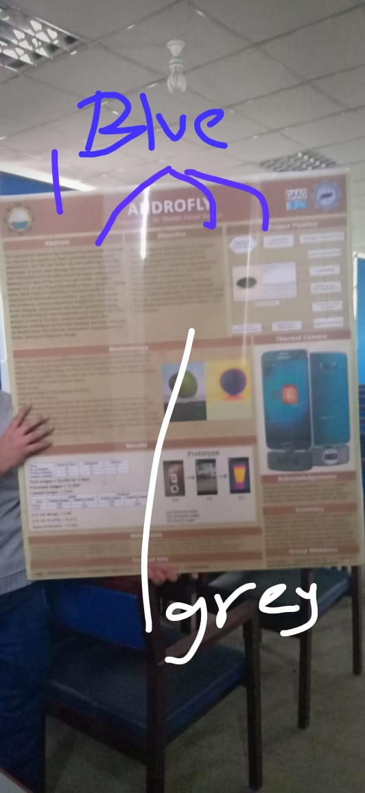**]**

* **Abstract**

The evolution of information society has led to the emergence of new technologies and environments. One of the most important requirements to such environments is the rapid access to the relevant knowledge that meets person’s needs as precisely and fully as possible. This semantic base knowledge Learner is about building an appropriate system to run around the Web performing scheduling tasks for their users. As in previous system, the role of meeting scheduler is mainly done by a person who is conducting a meeting or going to be a part of a meeting which can cause misinterpretation also or it can be just skipped from our mind but, in our knowledge learner, system will be more secure and lessen the burden to store and extract schedules for meetings. Mainly, developed to assists humans in office environments to schedule meetings efficiently. The main challenge behind meeting scheduling is the fact that one participant is only familiar with her own calendar events and thus only knows which times are suitable for her and not the others. So, to be able to compare everyone’s free times, and to find the time that is suitable for all, the free times need to be approved by all. This system provides the platform for store the information of user meeting at the time of meeting scheduling and then later, that user can access the details of meeting very easily.

* **Objective**

**Industry Objectives:**

The main objective of semantic base knowledge learner is to store the information and can be inference the particular information according to user query. To achieve the goal manually it takes too much time. Thus, by developing such application, saves a lot of time as well as improves performance and user can extract the desired information anytime and anywhere. So, Semantic based knowledge learner is the meeting scheduler that stored the information and can be inference quickly.

**Research Objectives:**

In the development of Semantic based knowledge learner, graph database (NEO4J) used. Graph databases are very vital in the field of research as in relational database it is difficult to get unique and desired output quickly. Although there are some research issues with graph databases, however it has importance in the research field along with semantic web technologies. NLP (extract the useful information from text) and inferencing that need some research.

**(I removed the academic objective as I thing these 2 are enough) \\ is ko template sa remove kr daina**

\

* **System Flow Diagram (project pipeline*)**

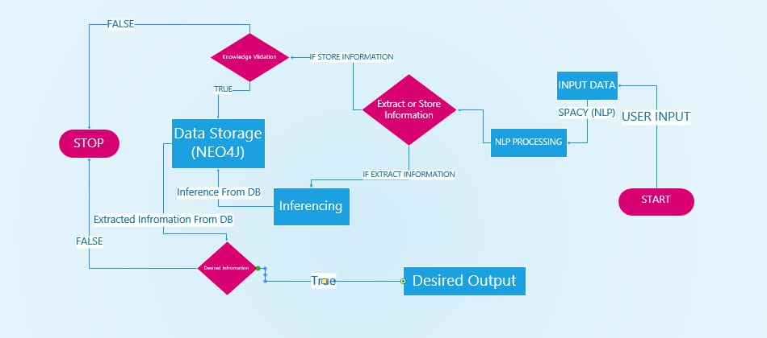

* **Methodology**

In Semantic Base knowledge learner, development is gradually using iterative and incremental methodology that divide the application requirement into different phases that implement.

1. Take the user input and after process this query using SpaCy (NLP) that extract the useful information and store in form of graph database
2. From the previous scheduled meeting database, inference the information while scheduling the upcoming meeting and rescheduled the meetings.
3. Knowledge Validation for upcoming meeting.
4. Inferencing of personal and meetings data on basis of user input.

These are all the major phases that implement during the development of Semantic Based Knowledge Learner and with all these phase basic phase are to be implement and then move toward complexity with increment of functionality to achieve the application requirements

* **Features (Thermal Camera*)**

1. Schedule a new Meeting

2. Reschedule upcoming meeting

3. Delete a meeting

4. Inference information on basis of personal data

5. Inference information on basis of Meeting data

6. Knowledge validation

7. List of all meeting

8. List of today's meeting

* **Project prototype (Results*)**

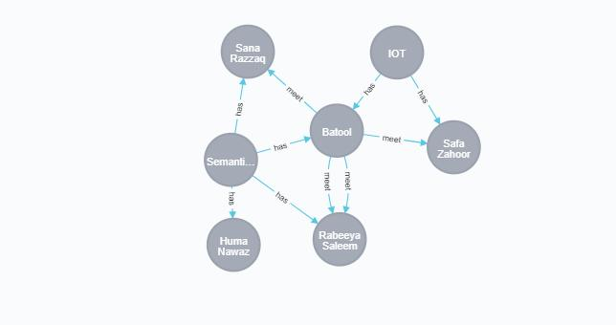

* **References**

**(3 to 4 lines…)**

* **Contact Info**

Muhammad Umair  
Contact: 03330937333  
Gmail: [mrumairbhatti9@gmail.com](mailto:mrumairbhatti9@gmail.com)

* **Acknowledgements**

We thank to etc…. (3 to 4 lines)

* **Future Work (Summary*)**

1. Voice based.

2. Mobile application

3. Multiple participant

(3 to 4 lines…)

* **Project Members**

Muhammad Umair (2015-CS-5)

Rabeeya Saleem(2015-CS-5)

Huma Nawaz (2015-CS-5)

Batool Gohar (2015-CS-5)